PA3CLQ's Leuke Linken Nr. 510

[slowspeedwire] Shorpy Historic Picture Archive :: Ouray Depot: 1940 high-resolution photo
D&RGW depot in Our at Colo.
http://www.shorpy.com/node/23761?size=_original#caption
http://www.shorpy.com/node/23769?size=_original#caption
http://www.shorpy.com/node/23771?size=_original#caption
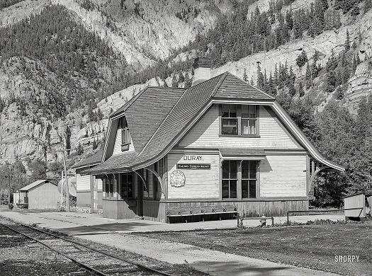
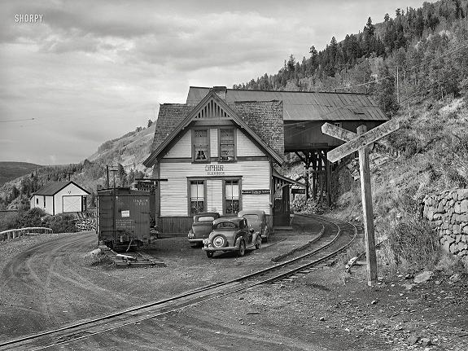
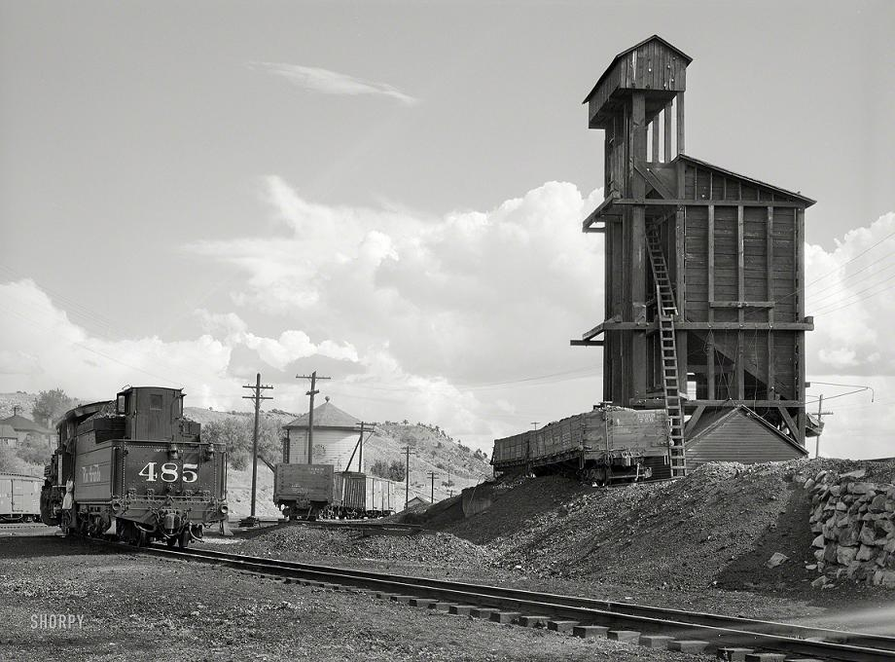

Joe N0PME
SHORPY Archave at:
http://www.shorpy.com/
http://www.junipergallery.com/
Editor

Unortunately, this beautiful depot burned to the ground and took a power line with it.....
which zapped a bunch of stuff in the RGS depot at Ridgway D&RGW Jct and darned near burned that one too.
Lake Trump

It looks like the Rdigway depot now houses the Ouray County Ranch History Museum
http://ocrhm.org/
and of course the railroad museum you mention is at:
http://www.ridgwayrailroadmuseum.org/
The "Historic Photos" link on this page has lots of interesting images.
The ranch museum makes comment about wanting to move to a larger place so maybe the depot might once again become a railroad museum.
One can at least hope, at least it has been preserved.
I've recently been watching a video I got some years ago from Green Frog Productions which has a lot of footage of the RGS and D&RGW NG taken from the late 30's to the very early 50's.
73, Chris

Speaking of old depots,
my college friend on his cross country road trip also visited the little town of Wallace, ID which has a very attractive small former NP depot, now a museum
http://www.npdepot.org/
While there my friend mentioned the availability of an Internet Morse system and the staff member with whom he spoke indicated a strong interest in it.
So I located their web site (and there's a lot more about this depot on the web as well) and sent a long email identifying myself and describing MorseKOB, the MTC, "Dots & Dashes" and offered to provide any help to them to set up an authentic telegraph office that I could.
We will see if I get any response.
At first pass I don't see that they currently have any telegraph set up in the museum but if any of you are out that way, you might want to take a trip to Wallace and check it out and report back.
73, J. Chris Hausler

I picked up a 3d printed key at boxboro this weekend. does anyone know where it came from?
I do not find any quite like it online.
It has pretty good feel.

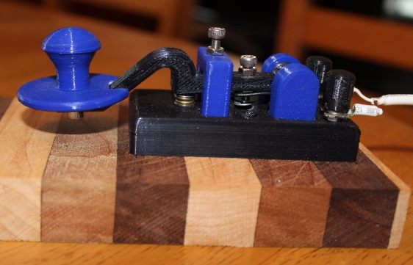
Thanks, Barry NF1O
I think this is the manufacturer:
http://cwmorse.us/
I have one of his keys that I use alot.
73, Craig WB3GCK
See this two projects:
https://www.thingiverse.com/thing:1516724/
https://circuitsalad.com/2016/08/09/build-a-3d-printed-telegraph-key/
There are many others in:
www.thingiverse.com
73's Carlos Fonseca, CT1GFQ
Morse News Direct Twitter
I made a film to show how I am doing this.
The signs are reverse in the film
https://www.youtube.com/watch?v=NqCnMJbKlm4
Gtidler

Just got a new computer, has no serial or parallel ports -
wondering what the most cost effective way for N1MM to key my transceiver would be?
de Wb8yqj Don
Don,
Use the DTR/RTS signals in your 7300's virtual serial port (via the USB cable) for PTT and CW keying.
Menu->Set->Connectors->USB SEND/Keying
No equipment purchase necessary and works really well.
Björn SM7IUN
Don, its Mortty
http://mortty.info/mortty/mortty-order-info/
If your radio doesn't have a USB input for directly keying the radio from the computer, it is questionable what the most cost effective way is.
The classic resistor+transistor to a serial port may not be the least expensive.
It depends on your junkbox.
These days, you will need a USB-to-serial converter ($15) plus a transistor+resistor interface to the CW jack on the radio (more $).
For $25.50, including shipping, the Mortty gives you a Winkey clone and the computer USB interface cable.
All you need to add is the cable from the Mortty to the radio.
The Mortty side is a standard 1/8" (or 3.5 mm) jack.
73, Steve, N2IC
Don
Mortty, as Steve notes, is a great choice, and is an emulator of Winkey that WB9SBD mention.
It works well and has the advantage of being very standard and compatible with all of your transceivers.
73, Drew K3PA
Don,
your question is wide open!
You'll have to use USB to communicate between your new computer and your radio.
But exactly how you do that depends on which transceiver.
You show three different brands of radios, so which one are you referring to?
GIWagner

The best $18 you will ever spend Morttys
Saturday at the Boxboro Convention, I delivered the bulk of the 50+ Morttys ordered by YCCC members in a group buy I organized.
Morttys can be configured to be a K3NG Winkey emulator or a TinyFSK interface.
The purpose of both is basically the same - to offload timing-critical software to a dedicated Arduino processor so that you never have to worry about whether the speed or workload on your computer will affect CW or RTTY timing.
These devices are one inch square by 2" long.
They are small enough and cheap enough to throw in your luggage as backup on your dxpedition.
They cost $18 + 7.20/package shipping for up to three in a box.
However, if you order 10, they will waive CONUS shipping, making the net cost $18/Mortty for a group buy.
Contact K8UT for non-USA shipping.
The Mortty hardware was designed by our own K8UT and by N8AR and is very well done.
The build instructions would make the Heathkit manual team embarrassed.
They are that good.
Simply look at the link below to see more.
Why don't YOU do a group buy for your club?
I would suggest a click-bait title like I used on this to make people read the email.
The compelling value proposition of the Mortty should do the rest.
The Mortty team is not Mouser Electronics, so please coordinate with them on any group buys and give them time to acquire parts if you are planning a large purchase.
For details see
http://hamprojects.info/mortty/
K8UT and N8AR do not make a profit on the Morttys.
Be sure to thank them and the software authors, K3NG (Arduino CW Keyer) and K0SM (TinyFSK)
73, Tom - N1MM
The shipping to Europe is expensive at $35, I could do with 4 kits, anyone else in Europe interested in a group buy?
73, Conrad PA5Y
Paragraphs describing bulk purchases with free CONUS shipping or cheap international shipping have been added to the Mortty
Order Info page here:
http://hamprojects.info/mortty/mortty-order-info/
-larry (K8UT)
Thanks Tom for that Mortty plug <blush>
It should be noted that there is a third Mortty software option: nanoIO for FLDIGI by Dave W1HKJ.
He modified his code and fldigi to interface with Mortty and provide keyboard-switching between fldigi's CW and RTTY modes.
For those of you who operate fldigi - and particularly those who prefer non-Windows platforms - this may be a very attractive alternative.
To Conrad, PA5Y: I wish there were a cheaper way to ship Mortty to Europe.
UPS and FedEx charge over $100 for anything insured and tracked.
We will maintain that $35 USPS fee to Europe regardless of the quantity you order, so we wish you well.
In fact, if you want to be the official Mortty distributor in Europe, we'll send EU inquiries in your direction.
As Tom mentioned, Steve and I are not getting rich from this venture.
We're merely trying to promote modes where price and degree-of-difficulty have been barriers to participation.
This was all possible thanks to the efforts of those freeware authors K3NG (Arduino CW Keyer), K0SM (TinyFSK) and W1HKJ (nanoIO).
http://hamprojects.info/mortty/
-larry (K8UT)
Larry it’s a nice idea to be the EU distributor but want you really need is a retired guy.
I have to much work and with the best will in the world I would not make a good job of it.
Why don’t you contact someone like
https://www.schmidt-alba.de/eshop/
They are very good distributers in my experience.
I will buy some kits, lets just see if there are a few interested first.
I know that the shipping costs are not your fault!
Regards, Conrad PA5Y

Source for Parts
Perhaps this source would help:
https://www.2bradioparts.com/index.html
73, George K4GM
Here is a picture of Hank Svard's own KungsImport which he used at Goat Island Radio / SAG in Sweden.............
as well as the QST advertisement he ran for several months.
Sadly, Hank passed away several years ago from cancer.
He never became a radio amateur but he was an excellent sideswiper operator and a personal friend of minie.

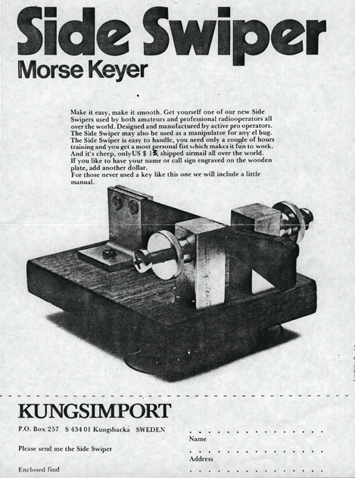
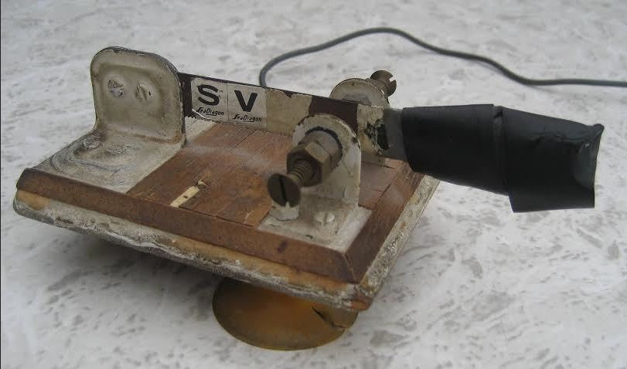

73, David Ring

Straight key or sideswipper
First I offer a suggestion: most of us sign our emails with our name and call or skcc number.
It helps us identify with whom we are communicating here and on the air.
Now, as to your question.
One reason that most of us have for suggesting a straight key is to help learn the proper character/word spacing.
Since you already know the code, and if you are confident of your ability to keep good spacing, there is not really a good reason you should not start with a cootie.
One way to help with the spacing concern is to listen to the ARRL code practice sessions.
They are available on line at :
http://www.arrl.org/code-practice-files
and have mp3 files up to 40 wpm.
Slower speeds start at 5, then go to 7.5, 10, 13, 15,18, 20, 25, 30, 35, 40 wpm and the QST source for the text is also there in a text file.
I’m trying to learn to copy using a keyboard so I’ve started listening to the 5 wpm for that purpose. I’m also trying to get my speed up and get to where I can head copy so I listen often to the 30,35, and 40 wpm sessions.
The higher speeds help with the slower speeds as I think my brain gets used to the rhythm of the code.
Just some random thoughts for your case.
I came back to the code after a many year absence and started with the straight key.
Again I found the practice mp4 sessions to be of great help.
That is what worked for me but your milage may vary.
I hope that helps.
Leslie Hock WB5JWI
Nice website:
http://www.n2amg.com/software/logger32-fldigi-gateway/
John, K3CT

Try This for more information
http://morse-rss-news.sourceforge.net/
Garry WW9GT

It has never been clear to me what is a Cootie Key...
So found some web links about em.
Maybe you would share there with the group.
(I have no commercial association with these links)
http://www.mtechnologies.com/wordpress/?p=26
http://www.mtechnologies.com/cootie.htm
http://www.mtechnologies.com/ghd/
de Jerry k6iii SKCCGroup

Folks,
A lot of good photos of cootie/sideswiper keys at SSN.org
http://www.sideswipernet.org/
A Vibrokeyer configured for cootie use is at :
http://out.easycounter.com/external/sideswipernet.org
There is a lot of good folks there to help and they have weekly nets for folks.
If I can get a rig on the air, I’ll try some cootie use this weekend.
I apologize in advance for how I’ll sound.
If I’m as bad as I fear I’ll be, I’ll go back to SK. Good luck to all.
Leslie Hock WB5JWI SKCCGroup

If it is a sideswiper, swiper, sweeper, double speed key or cootie,,,,
then when you press and hold either side of the finger piece you will be rewarded with tone as long as you hold the finger piece pressed.
If you press either side and receive a series of dits or dahs.......it's not.
There is also a difference in feel and technique between a rewired paddle and a traditional SS.
The traditional SS makes contact in front of the pivot and is flexible.
The rewired paddle makes contact behind the pivot point and made on a solid bar.
Press and hold either side of the lever. If you hear a single long tone as long as you press, it is a sidwswiper.
If it goes di di di di di...... or dah dah dah dah, It is not being used as a sideswiper.
Easy Peasy eh?
Randy_KB4QQJ

How to use a sideswipper
Interesting article on how to use a sideswipper
http://www.mtechnologies.com/cootie.htm
KB9SKP
Having no prior experience using a sideswipper.
I would like to ask everyone if they use the sideswipper the same way.
In the article by Jerry Bartachek KD0CA. HE states that with you thumb on the left side and index finger on the right side of the paddle .
You allway begin each character with the Index finger.
No matter if it's a Dit or a Dah
73 Ted KB9SKP
Ted -
It took me several years to feel truly comfortable and confident using a semi-automatic bug.
Therefore, when playing with a sideswiper, I start each character the same as I would with the bug (or paddle keyer).
Being right handed, if the character starts with a dit, then I start with the thumb.
Otherwise, I start with the index finger.
Once started, I alternate index/thumb and find it easiest the less I think about it.
Ron, AC2C
Regarding HOW TO USE A COOTIE,
let me offer this reminder that at my QRZ page I have accumulated a mix of those documented ideas, suggestions, and recommendations.
Also, don't forget that this topic has been addressed in multiple posts at "Cootie Corner" here in the groups.io distribution.
And now that we have a full weekend featuring Cootie bonus incentives, let me ask that as the Cootie lust builds and if you find yourself hooked (it is really easy to do), then please honor us with your presence on our SKCC Cootie User's list which is found at a link at my QRZ page.
As of this morning that list accounts for 120 SKCC members.
Please come in and join the bragging rights with the others of us Cootie users.
If you happen to be in the market for a Cootie key, you might peruse that same User list where members have listed their own inventory of cooties.
Check out the breadth of types and makes, and please consider and feel free to contact any member(s) on that list to learn about one's particular key selection and what he/she thinks of it.
In the event that search proves fruitless in turning up a key for your desires, I can offer simple tips if you wish to consider a cheap and quick homebrew project to build your own key.
Good luck .
Cheers, Mike, K5MP,
I believe there's no right or wrong method other than each character must be formed by alternating thumb and finger(s).
Since I also use a bug (and keyer) I start each character the same way as I do on a bug, dits with the thumb and dahs with finger and alternate back n' forth from there.
This makes it easier for me to switch keys...
John K7FD
Even more articles, tutorials, videos, audio recordings:
http://www.sideswipernet.org/resources.php
I found myself in the same situation as Ron, being a bug sender and not wishing to get confused.
Years ago I wrote this article:
http://sideswipernet.org/articles/n1ea-sending.php
which is on the Sideswiper Net pages, and it has some recordings which might be of interest if not value.
I highly recommend this method as it is much less confusing to the brain.
I can send with keyer, hand key, sideswiper, bug, by using this method, nothing gets too confusing.
73, David Ring N1EA
The only real original authentic site since years for FB information regarding SideSwiper's, I think is:
http://www.sideswipernet.org/
Editor

Hello Friends
A Coronal Hole Sandwich with a Side of Aurora: Solar Storm Shortie 09-04-2018
https://www.youtube.com/watch?v=GRjrIQYVZ6A&feature=em-uploademail
"The Sun may be spotless and quiet right now, but it wont last. ..."
"... amateur radio operators and emergency responders have a another week to wait for decent radio propagation. ..."
"... solar flux has tanked ..."
Not the latest from Tamitha Skov:
https://www.youtube.com/watch?v=elz2AuUMBfo&feature=em-uploademail
"... Radio propagation remains poor due to the spotless Sun, but active regions on the Sun's backside hint that a reprieve may be coming in about two weeks. ..."
Solar Storm in Time For Hurricane Florence: Solar Storm Shortie 09-11-2018
https://www.youtube.com/watch?v=nbvCD8ixcoc&feature=em-uploademail
"Emergency responders to Hurricane Florence should be aware that amateur radio and GPS will likely be affected through Thursday. ..."
"...New bright region ... has boosted the solar flux up to marginal radio conditions. ..."
Cheers, Darrel, aa7fv.
I’m one of the folks who keeps looking on the
https://www.lnrprecision.com/
website for the new sideswiper.
I’m trying to behave myself while patiently waiting to see the order page, Hi Hi.
Anyway, looking forward to the new key.
Don’t rush it, and I’m sure that we all appreciate you doing this for us.
Steve-KI4EZL
Have a nice day / week(end) gents, BCNU.
73, Yann, F5LAW
http://www.sideswipernet.org/
By OM Yann F5LAW SideSwiperNetGroup

73, from the town at the rivers "De Bergsche Maas" and "De Dongen" Geertruidenberg (800+ years city rights) at: 51.702211N 4.853854E
Editor Jan Pieter Oelp PA3CLQ

-30-

pa3clq@casema.nl
My simple website about Gigantic DF-Antennas
Part 1 "DF-Antenna Wullenweber Array"
Part 2 "DF-Antenna USSR Variants"
Part 3 "DF-Antenna USA Variant"
Next Part 4 "USSR OTHRA DUGA 1,2 & 3" at:
www.pa3clq.nl/

