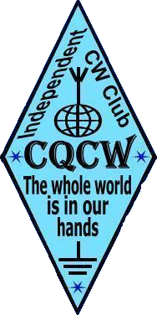
TERRE DES HOMES
CALL _______________
NAME ______________
Diploma name | Diploma number (3rd class) | Date of issue
Seven Wonders of the World
Mountain Peaks
Blue Lakes
Rivers of the World
Fata Morgana
Great Mariners
Green Planet Earth
Greenwich Meridian
Tropic of Cancer
Tropic of Capricorn
Equator

The last letter of the callsign | Bands, Mc | Continents | Call | Date | Band, Mc
S | 1,8  3,5  VHF  UHF | ALL
I
M
A
K
S | 7  10 | ALL
A
K
H
A
R
O
V
E | 14  18 | ALL
I
N
S
T
E
I
N
L | 21  24  28  50 | ALL
E
N
N
O
N

S | ALL | EU
A
I
N
T
E
X
U
P
E
R
Y
S | ALL | AS
C
H
W
E
I
T
Z
E
R
R | ALL | SA  NA
E
M
A
R
Q
U
E
K | ALL | AF  OC  AN
U
R
T
Z

Date ________________

